ONLINE EXAM PORTAL

Class Diagram:

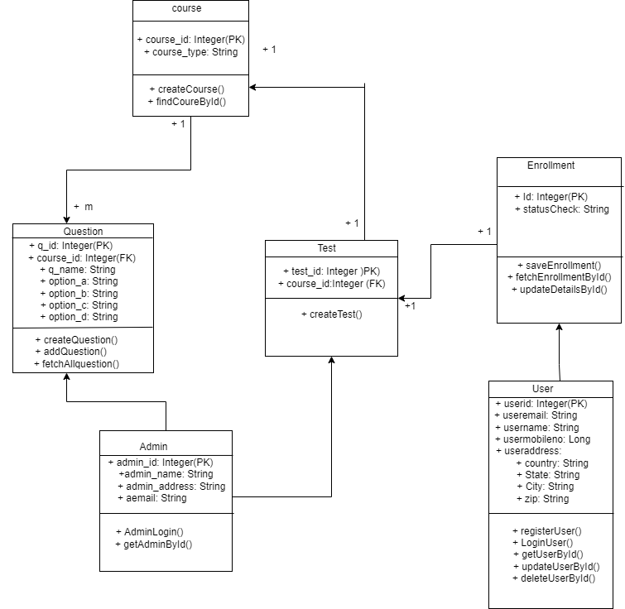

Use case Diagram:

